The University of Azad Jammu & Kashmir, Muzaffarabad


Name: Alishba Zakir
Roll no: 2024-SE-02
Course Title: Computer Networks
Submitted to: Engr. Asma Javaid
Semester: 04
Lab N0: 07

Table of Contents
1. Objective ..........................................................................................................................................
3 2. Theory and Key Concepts ............................................................... Error! Bookmark not defined. 3. Materials / Software Used ............................................................... Error! Bookmark not defined. 4. Procedure .......................................................................................... Error! Bookmark not defined.
- Configuration Commands ............................................................... Error! Bookmark not defined.
- Summary Table ...............................................................................................................................
- Observations and Results ................................................................ Error! Bookmark not defined. 8. Learning Outcomes ........................................................................................................................ 7
9. Conclusion .......................................................................................................................................

Lab No: 08

➢ Objective
The primary objective of this laboratory exercise is to develop a solid understanding of router access methods and to gain practical proficiency in using the Cisco IOS Command Line Interface (CLI). Specifically, the lab aims to:
- Familiarize students with console port access and connection methods.
- Introduce different Cisco IOS operational modes and mode-transition commands.
- Demonstrate basic device configuration, password security, and configuration file management.
- Develop essential skills for initial router setup and configuration.
➢ Theory And Key Concepts:
Network devices such as routers and switches require proper configuration before deployment. While modern devices offer web-based GUI interfaces, the Command Line Interface (CLI) remains the preferred method among network professionals due to its precision, scripting capability, and extensive feature access.
Major CLI Modes in Cisco IOS:
- User EXEC Mode (Router>) — Basic monitoring mode with limited commands.
- Privileged EXEC Mode (Router#) — Advanced monitoring, debugging, and access to configuration modes (accessed via enable).
- Global Configuration Mode (Router(config)#) — Used to make device-wide changes (accessed via configure terminal).
Configuration Files:
- Running Configuration — Currently active configuration stored in RAM (show running-config).
- Startup Configuration — Saved configuration stored in NVRAM, loaded after device reboot (show startup-config).
Basic Security Practices:
- enable password — Traditional (weak) password protection.
- enable secret — Strongly encrypted (MD5) password (preferred).
- service password-encryption — Applies Type 7 encryption to all plaintext passwords in the configuration.

➢ Materials / Software Used
- Cisco Packet Tracer
- Router (2911 model)

➢ Procedure
- Opened Cisco Packet Tracer and placed a router in the workspace.
- Accessed the CLI tab of the router.
- Navigated through different IOS modes.
- Performed basic security configuration.
- Viewed and saved configuration files.

➢ Configuration Commands
Step 1: Entering Privileged EXEC Mode
Step 2: Entering Global Configuration Mode
Step 3: Setting Enable Password and Enabling Encryption
Step 4: Configuring Enable Secret
Step 5: Viewing Running and Startup Configurations Step 6: Saving the Configuration


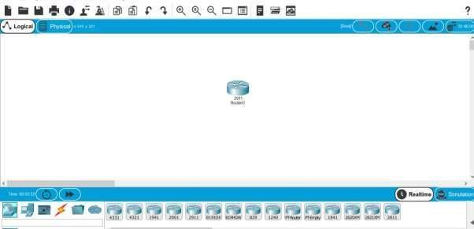

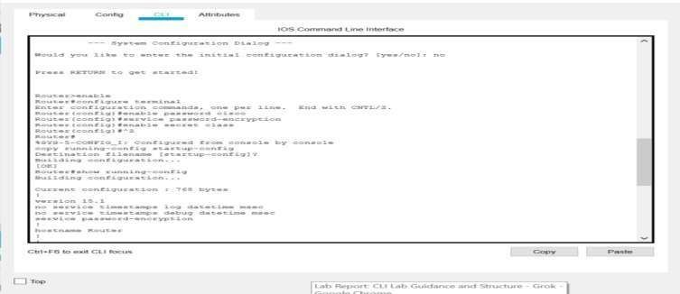

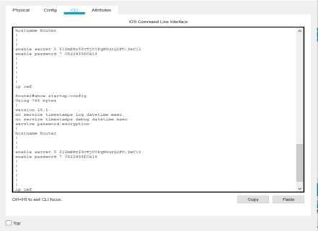

➢ Summary Table
Command | Mode | Purpose
enable | User EXEC | Enter Privileged EXEC mode
configure terminal (conf t) | Privileged  EXEC | Enter Global Configuration mode
enable password <pass> | Global Config | Set basic privileged mode password
service password-encryption | Global Config | Encrypt plaintext passwords
enable secret <pass> | Global Config | Set strongly encrypted privileged password
show running-config | Privileged  EXEC | Display current active configuration
show startup-config | Privileged  EXEC | Display saved configuration
copy running-config startupconfig  (wr) | Privileged  EXEC | Save configuration to NVRAM
end / Ctrl+Z | Any Config mode | Return to Privileged EXEC mode

➢ Observation And Results
- Successfully accessed the router CLI and transitioned between all major modes.
- Configured both basic and secure passwords. The enable secret takes precedence over enable password.
- Password encryption was applied correctly.
- Configuration was successfully saved from running-config to startup-config.
- All commands executed without errors, and outputs were as expected.

➢ Learning Outcomes
This lab provided foundational knowledge of Cisco device management. Key takeaways include:
- The importance of understanding CLI modes to avoid configuration mistakes.
- The difference between running and startup configurations and the critical need to save changes.
- Basic security practices to protect administrative access.
- Confidence in using CLI, which is essential for CCNA-level and real-world networking tasks.
The simulation in Packet Tracer closely mimics real hardware behavior, making the skills learned directly transferable.

➢ Conclusion
The lab objectives were fully achieved. Proficiency was gained in basic router CLI access, mode navigation, configuration management, and elementary security implementation. These skills form the cornerstone of network device administration.

